University Of Engineering and Technology, Lahore
Computer Engineering Department

Course Name: Programming Fundamentals | Course Code: CMPE-112L
Assignment Type: Lab tasks | Dated: 16 March 2026
Semester: First | Session: 2026 Spring
Lab/Project/Assignment #: 1 | CLOs to be covered: CLO 1
Lab Title: While Loops | Teacher Name: Hafiz Muhammad Mubashar
Lab Evaluation:

CLO1 | Apply appropriate programming techniques to create executable programs to solve well defined problems
CLO1 | Level1 | Level2 | Level3 | Level4 | Level5 | Level6
(5)
Total |  |  |  |  |  | /5
Rubrics for Current Lab Evaluation
Scale | Marks | Level | Rubric
Excellent | 5 | L1 | Submitted all lab tasks, BONUS task, have good understanding.
Very Good | 4 | L2 | Submitted the lab tasks but have good understanding
Good | 3 | L3 | Submitted the lab tasks but have weak understanding.
Basic | 2 | L4 | Submitted the lab tasks but have no understanding.
Barely Acceptable | 1 | L5 | Submitted only one lab task.
Not Acceptable | 0 | L6 | Did not attempt
Week 3 LAB
While Loops
Lab Goals/Objectives:
• To understand and implement indefinite and conditional iteration using Python’s while loop.
• To learn how to manage loop control variables through manual increments, decrements, and user input.
• To master the sentinel value pattern to dynamically terminate a loop based on user interaction.
Equipment Required:

* Computer/Laptop
* Python 3.14
* VS Code or pycharm

Theory:
Unlike a for loop which iterates over a fixed sequence, a while loop in Python repeatedly executes a block of code as long as a given condition remains True.

Lab Work:

Task 1: Basic While Loop Iteration (Counting Up).
while i <= 5:
print(i)
i = i + 1

Result:

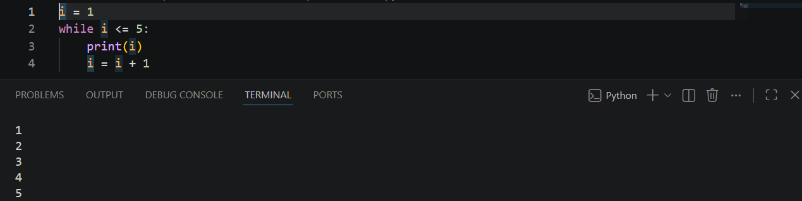

Task 2: Sentinel-Controlled Loop (Accumulation)
while num != 0:
total = total + num
num = int(input("Enter number: "))

Result:
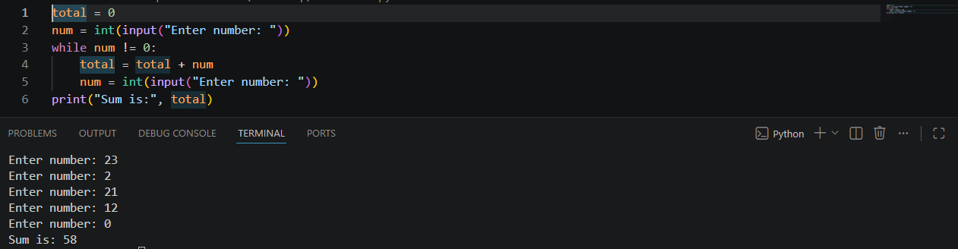

Task 3: Countdown Iteration
while n >= 1:
print(n)
n = n - 1
Result:
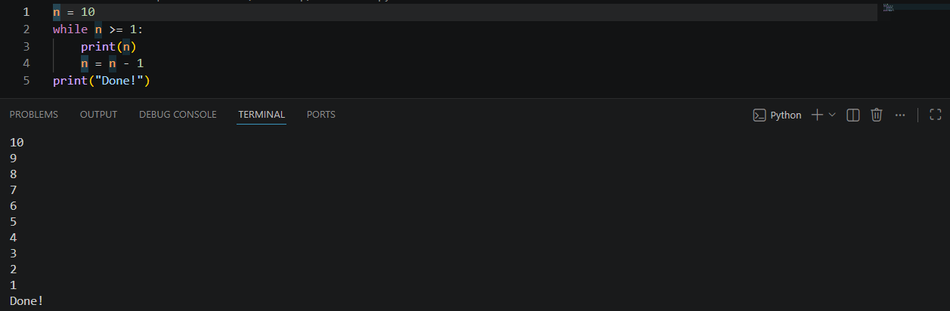

Task 4: Iterating with Step Increments (Even Numbers)
while i <= 10:
print(i)
i = i + 2
Result:

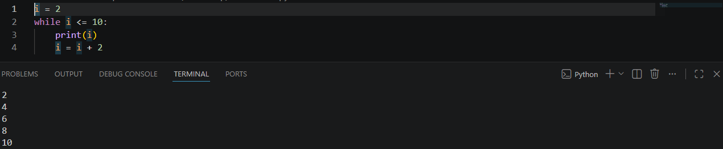

Conclusions:
This lab successfully demonstrates how while loops function in Python to handle condition-based repetition. By implementing countdowns, variable step increases, and sentinel values, we observed how while loops provide flexible control for scenarios where the exact number of iterations is unknown beforehand.

